Users & Groups Created
- Users: tokyo, berlin, professor, nairobi
- Groups: developers, admins, project-team
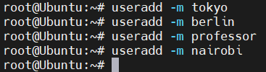
- Cat /etc/passwd
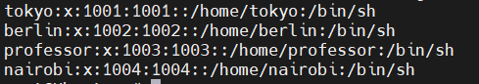
- Cat /etc/passwd
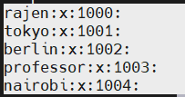
- Cat /etc/group
